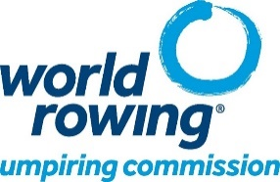

Jury Nomination Form for 2024 Olympic & Paralympic Games Regatta

The National Rowing Federation of ______________ herewith nominates the following World Rowing umpire as a candidate for the 2024 Olympic / Paralympic jury. The federation and the umpire commit themselves that – if selected – the umpire will attend the regatta.

Name:_______________________ First Name: ____________________________

Nationality: ____________ License number: ________

Last seminar attended: Place: _________________ Year: ________

Home address:
(if you are resident in a country different from your nationality, please make this clear)

Street: _______________________________ Number: _______

Postal code: ________ City: __________________ Country: ________________

Tel home: + ___________________ Mobile: +_________________________

E-mail: ____________________________@______________________

Is a Jury candidate for:

[_] 2024 Olympic Games Regatta in Paris, France (27 July – 4 August);

[_] 2024 Paralympic Games Regatta in Paris, France (30 August – 1 September);

Signature of federation Secretary General Signature of umpire
Date: ____ / ____ / 2023 Date: ____ / ____ / 2023

Please return to patrick_rombaut@telenet.be (copy to prateek.gumbar@worldrowing.com)
by 25 August 2023 (midnight CET).

