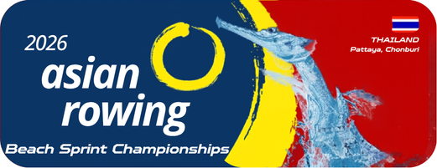
Annex 2
Final Entry by Name
2026 Asian Rowing Beach Sprint Championships

Federation:
Please note: A separate form must be completed for each event
Event and Event No.:
Crew Details:
 | No. of crew | Family Name |  | Given Name | Event
Declaration:
The undersigned Federation certifies that the above rowers nam and substitute(s) comply with the ARF statutes and the requirements of the FISA Rules of Racing. They are authorized to compete in this event as enter.

 | Authorized Signature & NF seal
 | Name and Position
 | Date (dd/mm/yyyy)
Please email to the OC rcatarfevents@gmail.com, and copy to ARF office@arfrowing.com
No later than 15 May 2026

