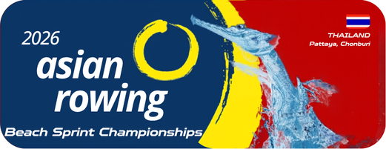

Annex 3
Accreditation Form – Athletes
2026 Asian Rowing Beach Sprint Championships

Federation:
Details of Participants:
No. | Last Name | First Name | Passport No. | Date of Birth | Gender | Event(s)
Remark: This form should be accompanied by copies of passport and photographs of each team member

Authorized Signature & NF seal
Name and Position
Date (dd/mm/yyyy)
Please email to the OC rcatarfevents@gmail.com, and copy to ARF office@arfrowing.com
No later than 15 May 2026

