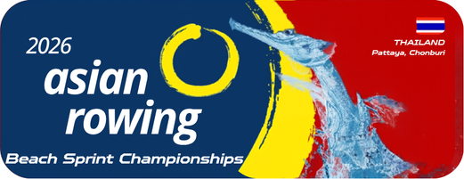

Annex 5
Accommodation Reservation
2026 Asian Rowing Beach Sprint Championships

Federation

Details of room types:
Room types | Price  (per person per night) | No. of room request | Total amount
Single | 120 USD
Twin (sharing) | 80 USD
Check-in date:
Check-out date:
No. of stay (night):

Special request:

Authorized Signature & NF seal
Name and Position
Date (dd/mm/yyyy)
Please email to the OC rcatarfevents@gmail.com, and copy to ARF office@arfrowing.com
No later than 30 April 2026

