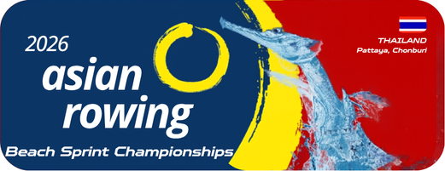

Annex 6
Transportation Reservation
2026 Asian Rowing Beach Sprint Championships

Federation:

Arrival Date:
Flight Details:
Departure Date:
Flight Details:
Number of Athletes:
Number of Officials:
Total Number of Participants:
Authorized Signature & NF seal
Name and Position
Date (dd/mm/yyyy)

Please email to the OC rcatarfevents@gmail.com, and copy to ARF office@arfrowing.com
No later than 15 May 2026

