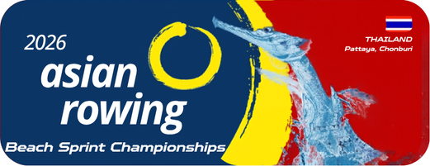
Annex 7
Request for Invitation Letter Form
2026 Asian Rowing Beach Sprint Championships

Federation |  | Country
Expected arrival date:
No. of stay (days)
Details of Travelers:
No. | Last Name | First Name | Passport No. | Gender | Expiry Date | Position
Remark: This form should be accompanied with copy of passport and photographs of each team member

Authorized Signature & NF seal
Name and Position
Date (dd/mm/yyyy)
Please email to the OC rcatarfevents@gmail.com, and copy to ARF office@arfrowing.com
No later than 30 April 2026

