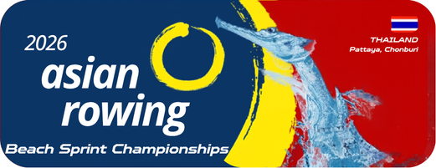
Annex 8
Boat Requirements
2026 Asian Rowing Beach Sprint Championships

Federation:

Entry fee may be collected from NF per event per boat

Event  No. | Event Categories | Entries
Event  No. | Event Categories | Solo Boat  150 USD | Double Boat  200 USD
1 | U16 CM1x
2 | U16 CW1x
3 | U16 M2x
4 | U16 W2x
5 | U16 Mix2x
6 | U19 M1x
7 | U19 W1x
8 | U19 M2x
9 | U19 W2x
10 | U19 Mix2x
11 | CM1x
12 | CW1x
13 | CM2x
14 | CW2x
15 | CMix2x

Remark- Entries fee will be calculated per boat per event.
(only once from time trial to final or less)
Please email to the OC rcatarfevents@gmail.com, and copy to ARF office@arfrowing.com
No later than 15 May 2026

